VIETNAM NATIONAL UNIVERSITY OF HO CHI MINH CITY INTERNATIONAL UNIVERSITY
SCHOOL OF COMPUTER SCIENCE AND ENGINEERING


FINAL REPORT
Website Project
Course: DSA-
ADVISOR:
Assoc. Prof. Nguyễn Thanh Tùng

Chapter 1: Introduction
The digital transformation of the fashion retail industry presents an exciting opportunity that blends modern web technologies with seamless customer experiences. Our project — the MIXER clothing website — reimagines the traditional clothing shop into a fully interactive online platform built with contemporary web development tools, allowing users to explore products, personalize their style, and shop with ease through a clean and intuitive interface.
This implementation is not just an online store — it is a demonstration of effective web application architecture. Each component, from product management to user authentication and shopping cart functionality, is structured following principles of modularity, scalability, and clean separation of concerns.
By applying essential software engineering principles — including responsive design, secure backend development, and maintainable code practices — we ensure that the system is robust, extensible, and ready for future enhancements, such as personalized recommendations, AI-driven styling assistants, and integrated payment gateways for a seamless shopping experience.

Group Project’s Member
No | Full Name | ID | Role | Contribution
1 | Trương Võ Hải Âu | ITCSIU23001 | Leader
2 | Dương Hoàng Đức Anh | ITITIU23002 | Member
3 | Nguyễn Minh Khoa | ITITIU23033 | Member
4 | Lê Bá Minh Khôi | ITITIU23012 | Member
5 | Lương Anh Khải | ITITIU23010 | Member
Table 1: The contribution and information of all project members

TABLE OF CONTENTS

Chapter 1: Introduction 2
Group Project’s Member 2
TABLE OF CONTENTS 3
Chapter 2: Tutorial 4
Chapter 3: Algorithms 5
I / Basic Sort & Search 5
1.1 Merge Sort 5
1.2 Binary Search 6
II/ Advanced Data Structures 7
2.1 Trie 7
2.2 Stack (LIFO) 8
2.3 Hash Table 9
2.4 Graph + Dijkstra 9
III/ Smart Search Algorithms 10
IV / Jaccard Similarity 11
V/ Smart Suggestion / Clustering Algorithm (AI) 12
5. K-Means Clustering 12
VI / Knapsack Problem 13
VII/ System Workflow when Deploying Algorithms 13
VIII / Conclusion 14
8.1 Summary of the Project 14
8.2 Application of Data Structures and Algorithms 15
8.3 Strengths of the System 15
8.4 Challenges and Lessons Learned 15
8.5 Limitations 15
8.6 Future Work 16
8.7 Final Conclusion 16

Chapter 2: Tutorial
You want to find our product you can use search field and it will give you hint of this product.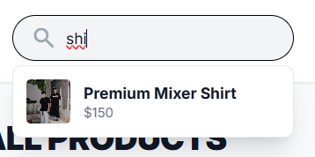
After that you can search the product with price.
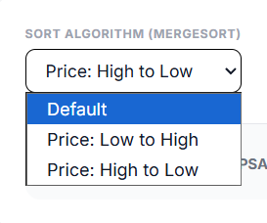
Or you can search with your funding.
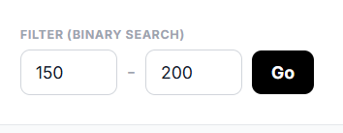
You also use machine learning to divide products to many groups for you to choose.

After you choose products you can go to your cart to see products and total value.
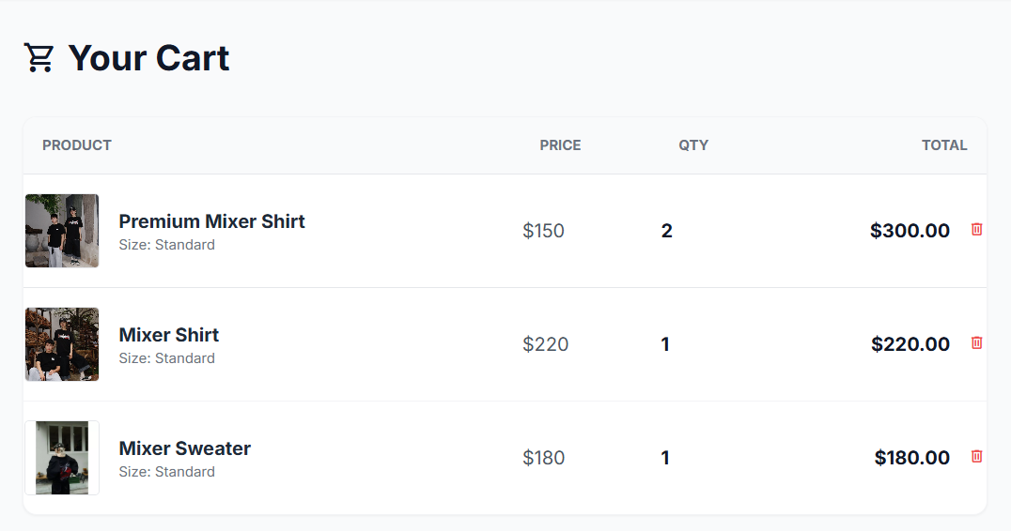
And choose your location it will give you a fee ship.
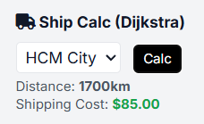
If you don’t know which product you can buy with your funding you can use smart budget it will optimize some products you can buy.


Chapter 3: Algorithms

I / Basic Sort & Search

1.1 Merge Sort
- Concept: Merge Sort is a sorting algorithm based on the divide-and-conquer paradigm.
- Operating Mechanism: Divide – Conquer – Merge
- Divide: Continuously divide the list into two equal halves until each sublist contains only one element.
- Conquer: Sort each sublist. (Sublists with one element are considered sorted).
- Merge: Merge the sorted sublists back together to form larger sorted lists until the entire list is sorted.
- Complexity : O(nlogn)
- This is the time complexity for the best, average, and worst cases.
- Applications :
- Sorting product prices.
- Sorting by relevance score.
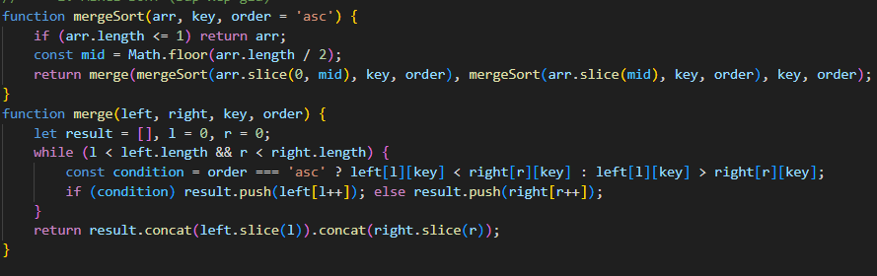

1.2 Binary Search
- Concept : (The detailed concept section is blank in the image, but this is the general meaning: Binary Search is an efficient search algorithm for finding an item from a sorted list).
- Operating Condition : The data must be sorted beforehand.
- Complexity : O(logn)
- Applications :
- Filtering products by price.
- Fast searching on already sorted data.
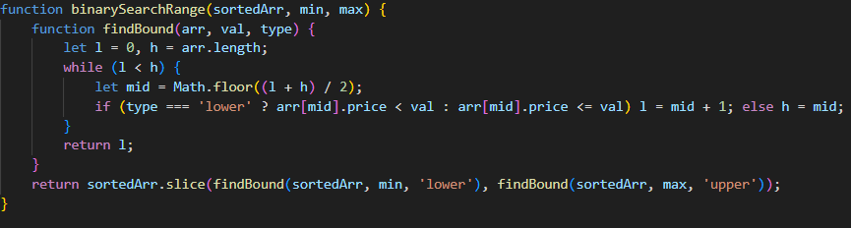

II/ Advanced Data Structures

2.1 Trie
The Trie is a tree-like data structure used to store a dynamic set of strings. It is optimized for retrieving keys based on their common prefixes.
- Structure and Principle:
  - Each node in the Trie typically represents a single character.
  - Words are constructed by traversing from the root node downwards. The path from the root to any node represents a prefix of a string.
  - A special marker (often a flag) is used to indicate the end of a complete, valid word.
- Time Complexity for Insertion and Search: O(m)
  - m is the length of the string being inserted or searched.
  - Unlike Binary Search Trees (BST) or Hash Tables, which might compare entire keys, a Trie only requires a time proportional to the word's length to traverse the character nodes. This makes it extremely efficient for prefix-based operations.
- Applications:
  - Autocomplete when typing keywords: The most classic use case. When you type PRO, the Trie can quickly find all words that start with this prefix (like PROGRAM, PROJECT, etc.).
  - Suggestion for search based on initial characters: Used by search engines to provide instant, relevant search suggestions as the user types.
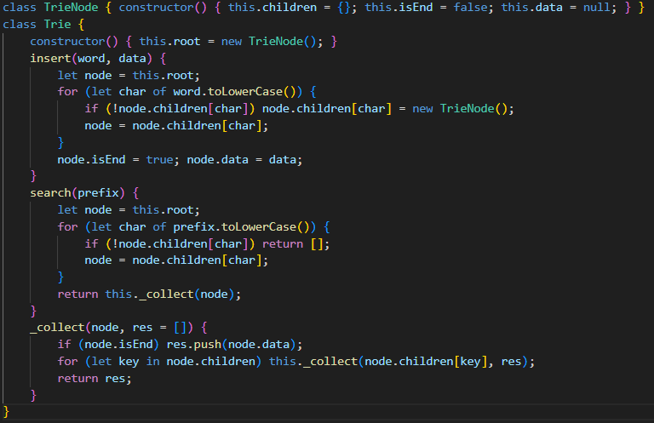

2.2 Stack (LIFO)
The Stack is a linear data structure that strictly adheres to one principle regarding the order of adding and removing elements.
- Concept (LIFO)
- LIFO stands for Last-In, First-Out.
- This principle means that the element that was added last will be the element to be removed first. It operates like a stack of plates: you can only add a new plate to the top (last in), and you can only take the top plate off (first out).
- Push / Pop Operations
  - Push: The operation of adding a new element to the top of the Stack.
  - Pop: The operation of removing and returning the element currently located at the top of the Stack.
- Applications:
  - The Stack's LIFO nature makes it essential for several programming applications:
  - Saving Product Viewing History (or Browser "Back" button):
    - When you visit a new page or product, it is pushed onto the Stack.
    - When you click "Back," the last page you viewed is popped off to return you to the previous state.
  - Undo / Redo:
    - Every user action (e.g., typing a word, drawing a line) is pushed onto an Undo Stack.
    - When the user clicks Undo, the last operation is popped from the Undo Stack, reversed, and often moved to a Redo Stack.
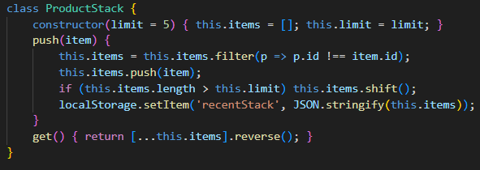

2.3 Hash Table
The Hash Table is a data structure that stores data as (key, value) pairs, enabling very fast data access.
- Hash Function
  - A mathematical function that converts a key into an index (or bucket/slot) in an array.
  - Its goal is to distribute data uniformly to minimize collisions.
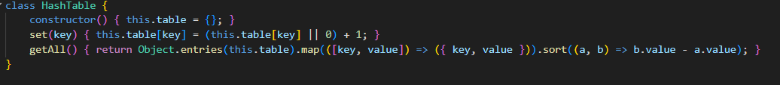

2.4 Graph + Dijkstra
- Concept of a Weighted Graph: A Graph is a collection of nodes (vertices) connected by links (edges). A Weighted Graph is one where each edge has a numerical value, or weight, representing the cost, distance, or time to travel between those two nodes.
- Dijkstra's Algorithm: A famous algorithm used to find the Shortest Path from a single starting node (source) to all other nodes in a weighted graph, provided all weights are non-negative.
- Time Complexity: O(E \log V)
  - This complexity is achieved using a Priority Queue to efficiently select the next node to visit. E is the number of Edges (links), and V is the number of Vertices (nodes).
- Applications:
  - Calculating shipping fees: Determining the cost based on the shortest/cheapest route between locations.
  - Optimizing the shortest delivery route: The core logic behind GPS and map services for finding the most efficient way to get from point A to point B.
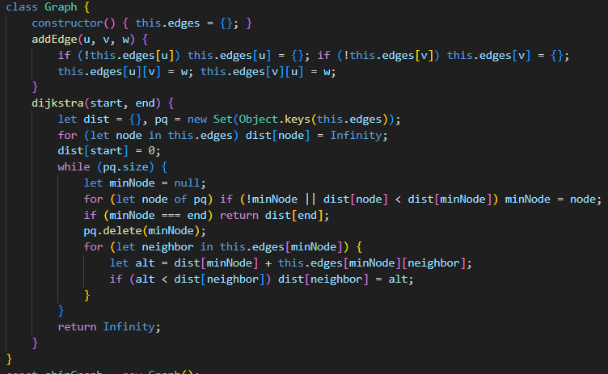

III/ Smart Search Algorithms
- Concept & Purpose
- Definition: The minimum number of single-character edits (insertions, deletions, or substitutions) required to change string A into string B.
- Purpose: Measures the difference between two strings (a smaller distance means the strings are more similar).
- Operation & Complexity
- Calculation Method: Uses Dynamic Programming with a matrix (table) to store the cost of transformations.
- Complexity: O(m x n) (where m and n are the lengths of the two strings).
- Applications
- Search Suggestions/Correction: Proposing the correct word when the user mistypes (e.g., "Did you mean: apple?").
- Spell Checkers.
- DNA comparison/analysis.
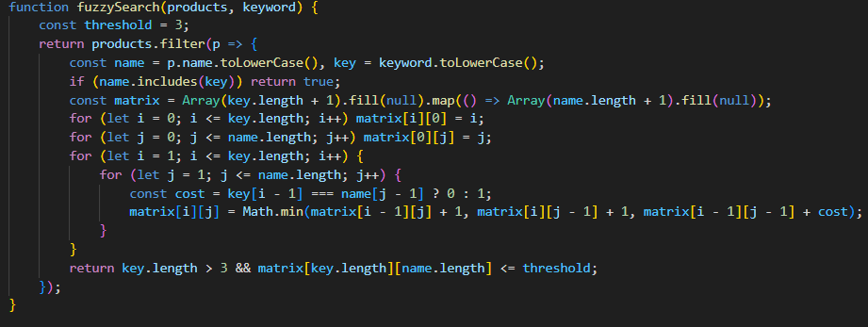

IV / Jaccard Similarity
  - Concept of Set Measure
- Jaccard Similarity measures the similarity between two sets.
- It is calculated by dividing the size of the intersection of the two sets by the size of the union of the two sets.
- The result is always a value between 0 and 1:
    - 1 means the two sets are identical (100% similarity).
    - 0 means the two sets share no common elements (no similarity).
  - Applications
- Suggesting similar products by tags, name, category: Used to determine the degree of similarity between products (e.g., if two products have 8/10 common tags, they have a high Jaccard Similarity and should be suggested together).
- Comparing the relevance between two strings: In Natural Language Processing (NLP), strings or text can be converted into sets of words or $n$-grams to compare their content similarity.
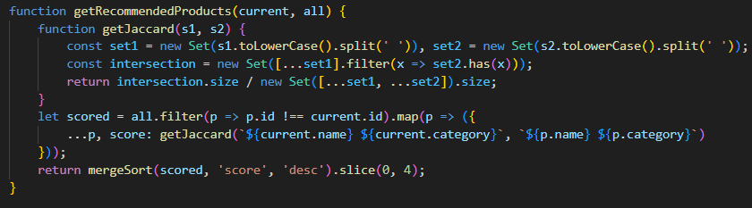

V/ Smart Suggestion / Clustering Algorithm (AI)

5. K-Means Clustering
K-Means is an unsupervised machine learning algorithm used for grouping data points into distinct clusters.
- Concept: It's an unsupervised clustering algorithm, meaning it finds hidden groupings in data without needing pre-labeled examples.
- How it works (Iterative Process):
- Select k centroids: Initialize k cluster centers (centroids) randomly.
- Grouping (Assignment): Assign every data point to the nearest centroid.
- Recalculate centroid: Update the centroid's position by calculating + the mean of all data points assigned to that cluster.
- Steps 2 and 3 are repeated until the centroids no longer move significantly.
- Applications:
- Grouping similar products based on attributes (price, category, features).
- Clustering-based suggestions: Recommending products based on the cluster a user or a product belongs to.
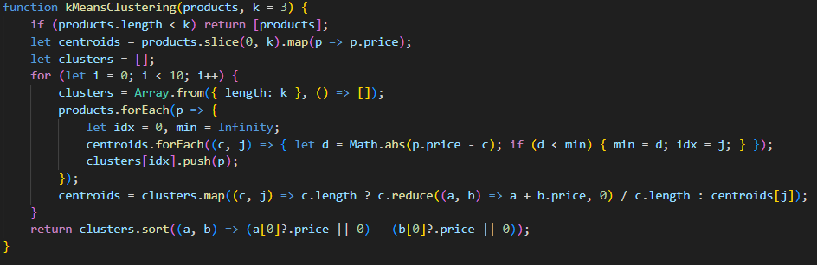

VI / Knapsack Problem
- Concept: Given a knapsack with capacity W and n items, each with a weight and a value. Each item can be either taken or not taken (0/1). The goal is to maximize the total value without exceeding the knapsack’s capacity.
- Dynamic Programming approach: Use a DP table to store the best possible value when considering each item and each capacity.
- Time complexity: O(n × W) where n = number of items, W = capacity.
- Applications:
- Shopping recommendations based on a budget.
- Selecting an optimal list of items based on value/price ratio.
- Resource allocation in optimization problems.
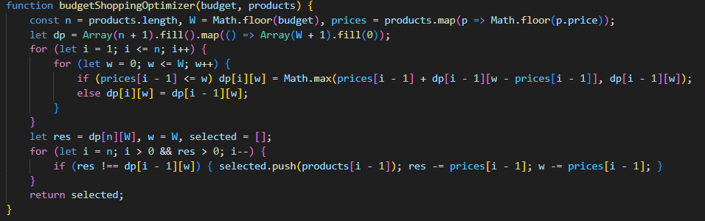

VII/ System Workflow when Deploying Algorithms
This section outlines how different algorithms work together to create a smooth and powerful user experience, particularly in an e-commerce or search environment.
- User inputs a keyword:
  - Autocomplete using Trie: As the user types, the Trie (Prefix Tree) quickly suggests possible completions for the word, enabling fast searching.
  - Fuzzy Search using Levenshtein: If the user makes a typo, the Levenshtein Distance algorithm is used. It calculates the minimum number of single-character edits (insertions, deletions, or substitutions) required to change one word into another, helping find the correct products despite spelling errors.
  - Sorted Data using Merge Sort: After searching, the results list (e.g., products) needs to be sorted (by price, rating, or relevance). Merge Sort is an efficient, stable sorting algorithm often used for large datasets.
- When the user selects a product:
  - Similarity suggestion using Jaccard or K-Means: The system uses advanced algorithms to recommend related items:
    - Jaccard Similarity: Compares two sets of data (e.g., product features or user purchase histories) to measure how similar they are.
    - K-Means Clustering: Groups similar products together. When a user selects a product, the system can recommend other items from the same cluster.
- When entering a budget: The system suggests the optimal purchase list (maximizing value) by utilizing the Knapsack algorithm.
- When calculating shipping cost: The Dijkstra algorithm is used to find the shortest path between the shipping point and the destination.

VIII / Conclusion

8.1 Summary of the Project
- The MIXER clothing website is an online shopping platform designed to provide users with a smooth and modern shopping experience.
- The project applied concepts from Data Structures and Algorithms (DSA) to implement essential features such as product management, searching, filtering, and shopping cart operations.
- The system demonstrates how theoretical DSA knowledge can be applied to build real-world web applications.

8.2 Application of Data Structures and Algorithms
- Various data structures were used to optimize performance, including arrays/lists for product storage, hash maps for quick lookups, and trees or sorted lists for filtering and sorting operations.
- Efficient algorithms were applied to manage searching, sorting, and updating product data.
- These implementations highlight the importance of algorithmic efficiency in building responsive web systems.

8.3 Strengths of the System
- The website offers a clean interface, easy navigation, and fast product interactions.
- Modular design ensures that each system component is independent and maintainable.
- The backend logic is built to be scalable, allowing the project to grow with new features in the future.

8.4 Challenges and Lessons Learned
- Integrating DSA concepts into real web development required careful planning and code organization.
- Managing data in a dynamic environment (adding/removing items in cart, filtering products) helped the team understand the role of efficient algorithms.
- The project improved the team’s problem-solving skills, teamwork ability, and understanding of web system architecture.

8.5 Limitations
- The current version may still lack advanced features such as payment gateways, recommendation systems, or inventory automation.
- Some operations can be further optimized as the number of products increases.
- User experience can be enhanced with more animations, personalization, and mobile optimization.

8.6 Future Work
- Implement AI-based product recommendations.
- Add secure online payment integration.
- Develop a full admin dashboard for product and order management.
- Improve search efficiency using advanced algorithms or indexing.
- Add caching strategies for faster data loading.

8.7 Final Conclusion
- The MIXER project successfully demonstrates how data structures and algorithms form the foundation of a functional and efficient online shopping platform.
- Through this project, the team gained both practical web development experience and deeper understanding of how DSA principles improve real-world application performance.
- The project serves as a meaningful stepping stone for future software engineering endeavors.

